***Screenshots :***

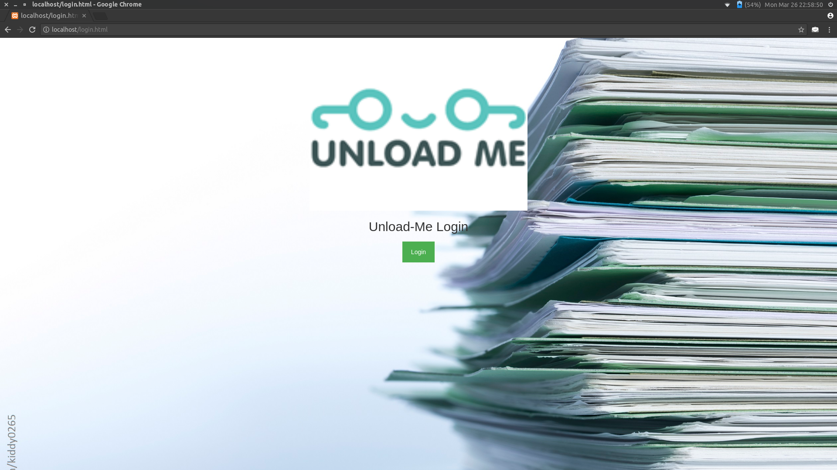***1) Main Page :***

***2) Login :***

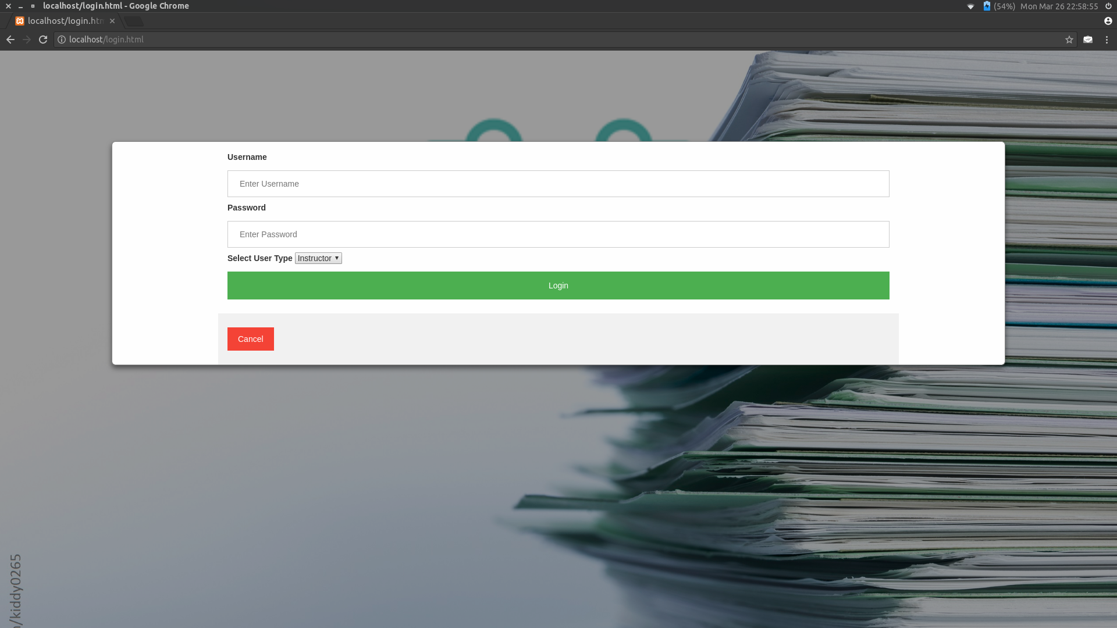

***3) Calendar UI :***

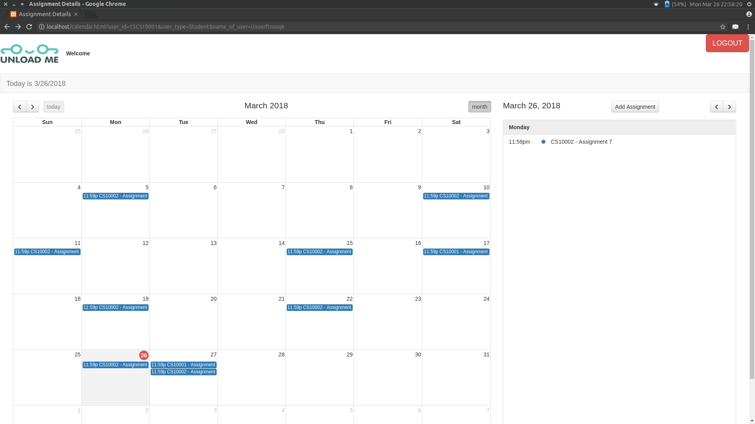

***4) Instructor adding new assignment and entering perceived difficulty:***

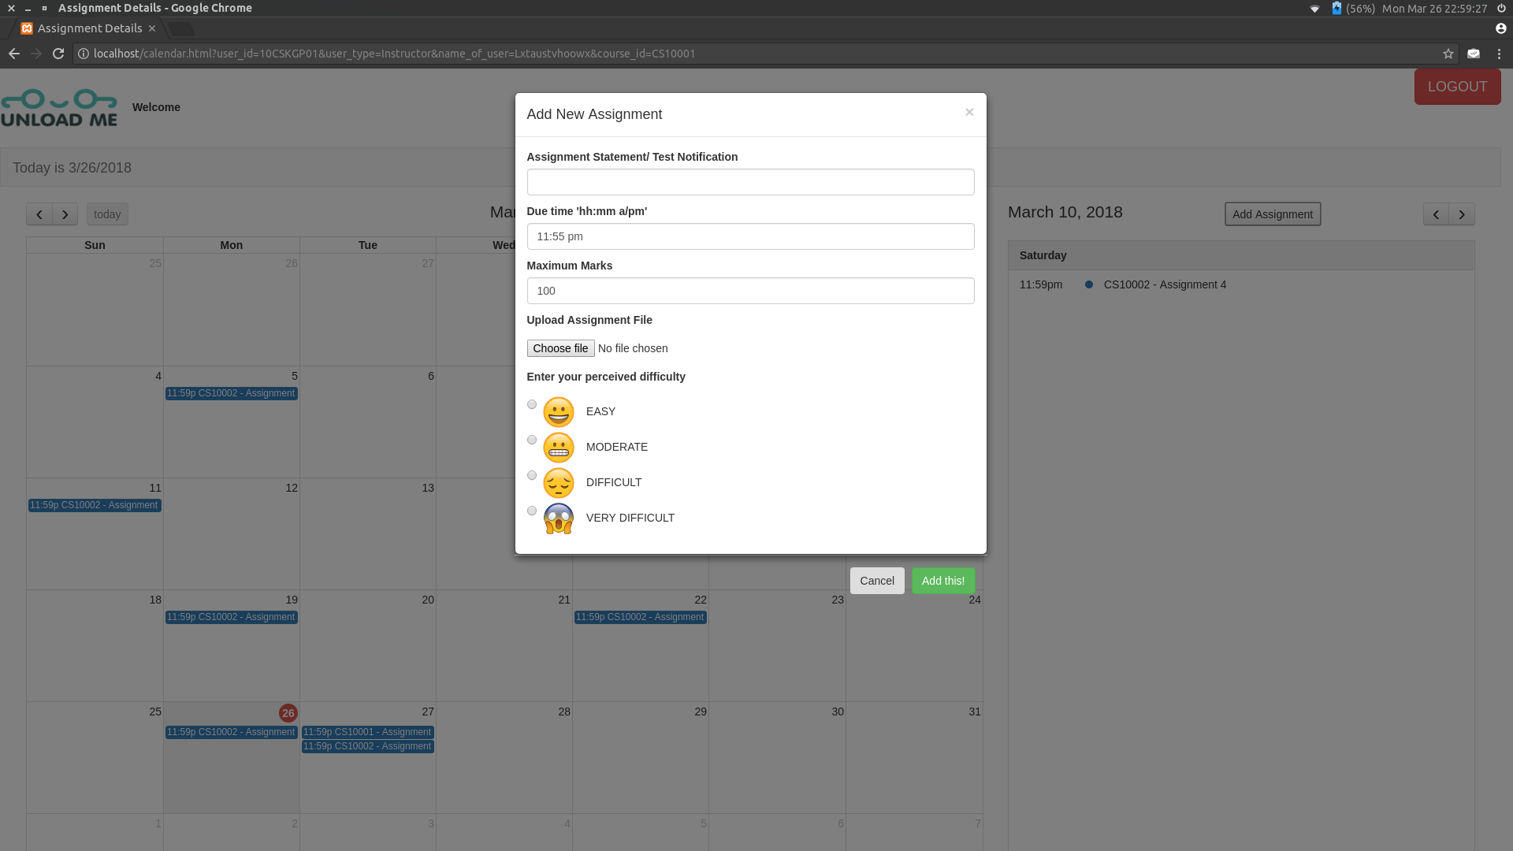

***5) Instructor updating/deleting assignment :***

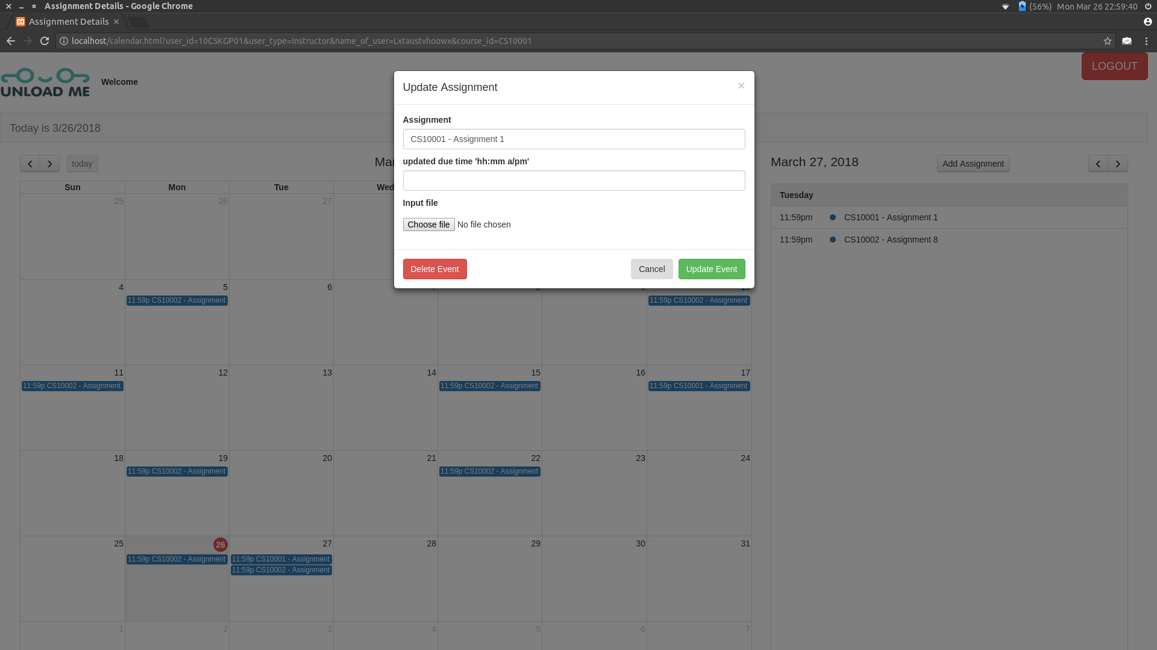

***6) Instructor blocked from accessing assignments of other courses :***

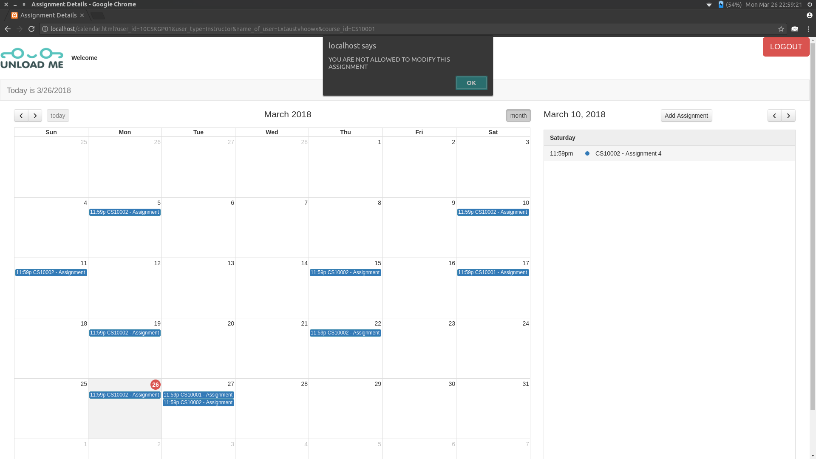

***7) Assignment submission and difficulty voting by the student :***

